W: SCS-K12.NET
ONLINE STUDENT ENROLLMENT
Navigate to the Parent/Guardian Login Portal. Please login if you already have an account created. If not, please select ‘Create Account’.

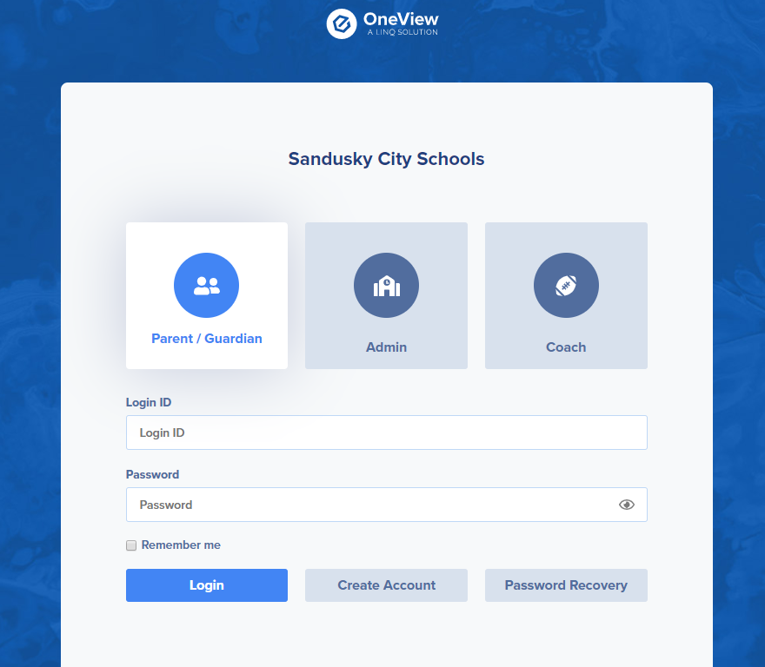
Click here to create a new account and register your students! This account will also be used to edit and update other district forms.
Login Boxes for previously created accounts
Helpful Hint:
Be sure the Parent/Guardian Box is selected!

CREATING A NEW ACCOUNT
Fill in all required fields and click ‘Register & Begin’.
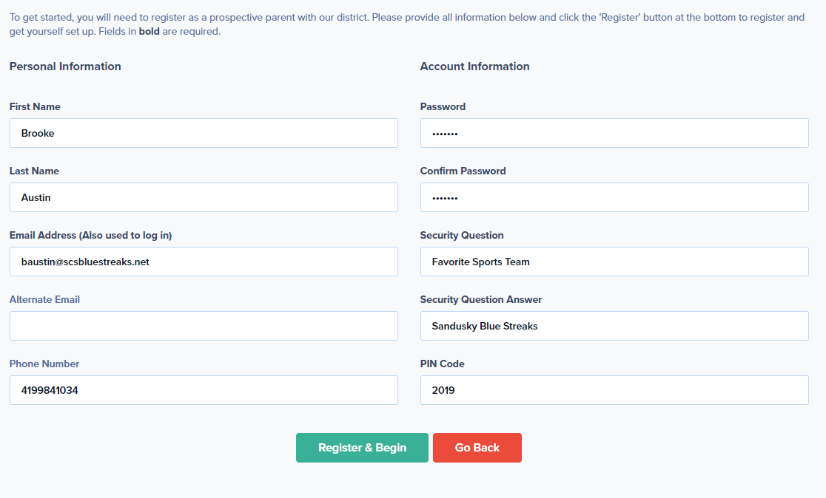

*Helpful Hint: Make your PIN Code something easy for you to remember. If you ever get locked out of your account district staff will use your Security Question/Answer and your PIN Code to insure your security and help you regain access to your account. You can always email marketing@scs-k12.net or call 419.984.1034 or 419.984.1114 for help.

ADDING A STUDENT TO YOUR PARENT HUB
Welcome to your Parent Hub! After enrollment of your students, they will appear on the left hand side of the screen. Alerts will also appear by your students’ name for updating forms, emergency medical information, physicals, address and phone number changes and more! We hope this online hub will make filling out your student’s required paperwork much easier every school year!
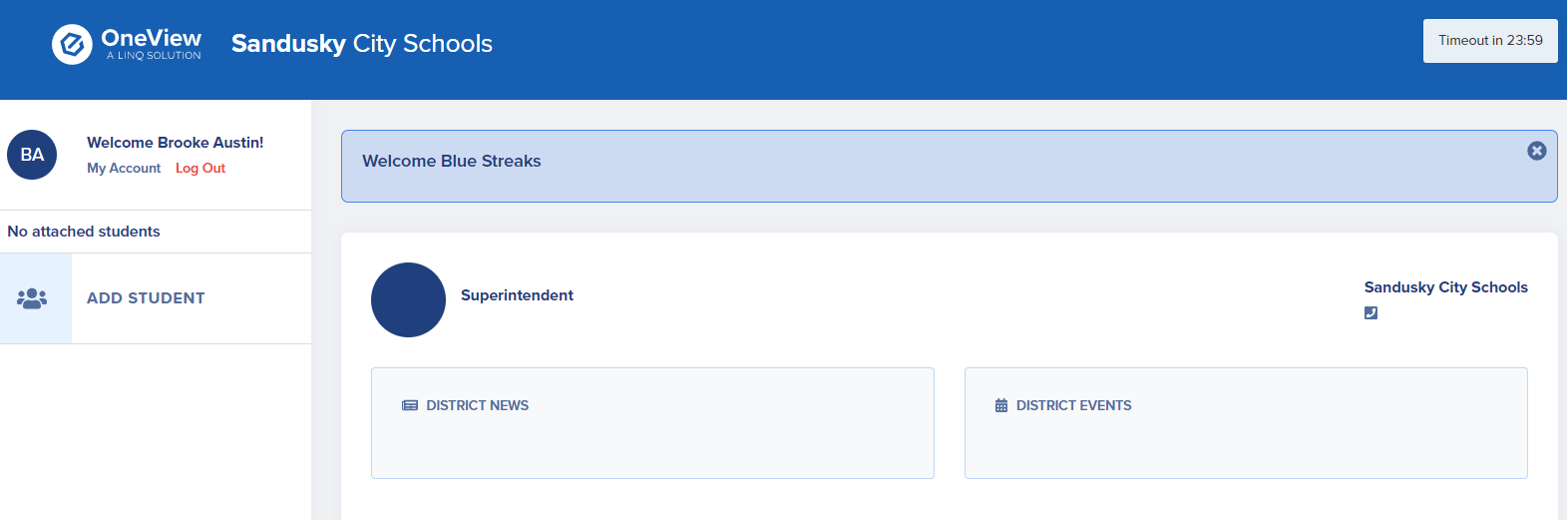
District News and Events will appear here.
Enrolled students and alerts will appear here.

To enroll/register a student online click ‘add student’. Then click “New to the district”.
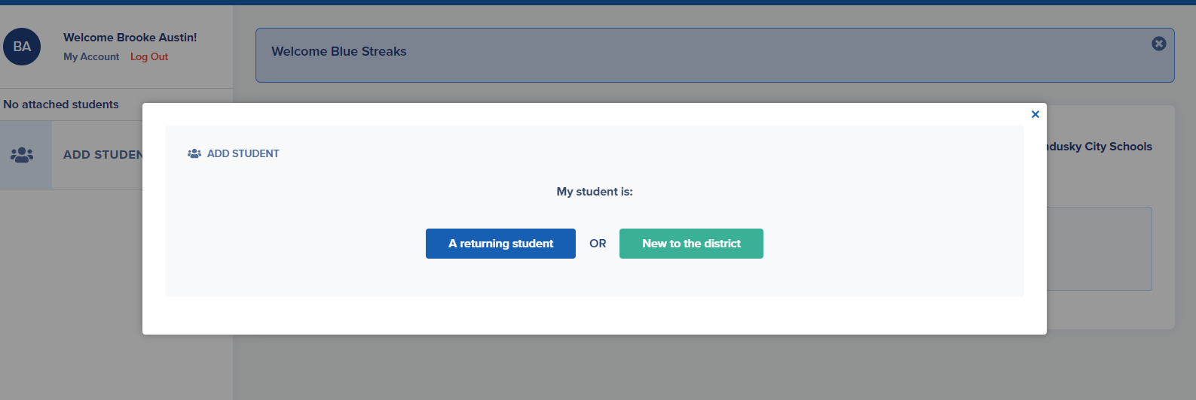
Complete the registration form. All required fields must be completed. Please let us know if you have any questions! We are happy to help!

Welcome to the Blue Streak Family!

