Cedar Point Stadium at Strobel Field Parking Directions

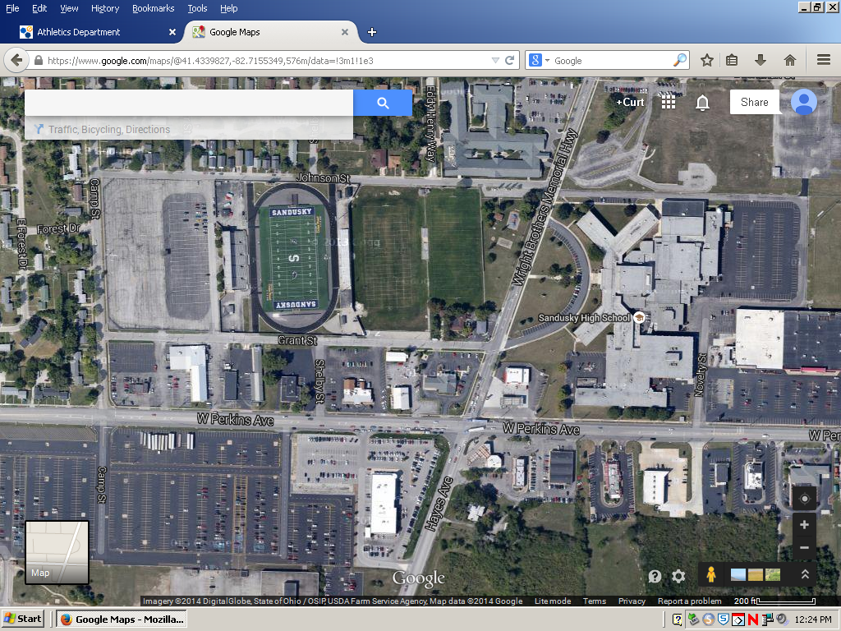

This is an aerial view of traffic flow for Cedar Point Stadium at Strobel Field for football or soccer games. Get off the turnpike (I-90) or Route 2 and head NORTH on Route 4 (Hayes Ave). Turn left onto Perkins Ave. Turn right on Camp Street, and then another right onto Grant Street. Parking is inside a fenced parking lot directly behind the home stands. The red rectangles are barricades that block off Grant Street. The orange stars are home team ticket booths. The yellow arrows represent ideal traffic flow. The green area is for busses unloading and emergency vehicle parking only. The dark blue star is the visitor side ticket booth. The light blue area is for bus parking only. The purple area is for paid parking. The gray area is for free parking.

